# Sound Sensor Module Experiment

## Introduction

The function of the sound sensor module is as a microphone (microphone). It is used to receive sound waves and display vibrating images of sound but it cannot measure the intensity of noise.

The sensor has a built-in condenser electret microphone that is sensitive to sound. The sound wave vibrates the electret film in the microphone which causes the change of the capacitance and generate a small voltage corresponding to the change. Then this voltage is converted into a voltage of 0-5V which is accepted by the data collector through A/D conversion and sent to the main control chip.

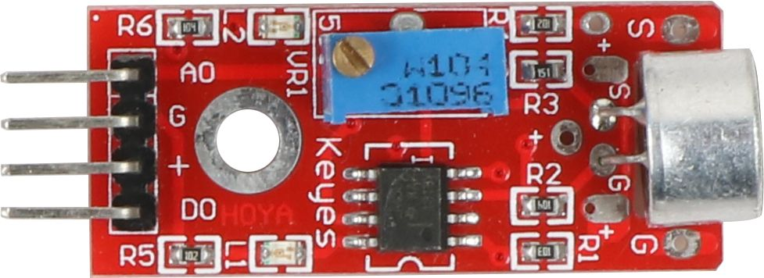

Sound Sensor Module

## Experimental Purpose

* Understand how the sound sensor work;

Learn to use Raspberry Pi board and sound sensor module to realize the function of sound control LED.

## Component List

* Raspberry Pi main board
* Raspberry Pi expansion board
* Cable
* Sound Sensor Module * 1
* LED Module * 1
* Several jumper wires

## Wiring

Connect the sound sensor signal AO pin to the Raspberry Pi A0 pin and connect the anode of the LED to the IO24 (wiringPi)/19 (BCM) pin of the Raspberry Pi board to complete the wiring of the entire experiment.

Sound Sensor Module Wiring

|  |  |
| --- | --- |
| Sound Sensor Module | Raspberry Pi |
| AO(signal pin) | A0 |
| G（GND） | GND |
| + （Power Supply） | 5V |

LED Wiring

|  |  |
| --- | --- |
| LED Module | Raspberry Pi |
| G（GND） | GND |
| R（pin） | IO24(wiringPi)/19(BCM) |

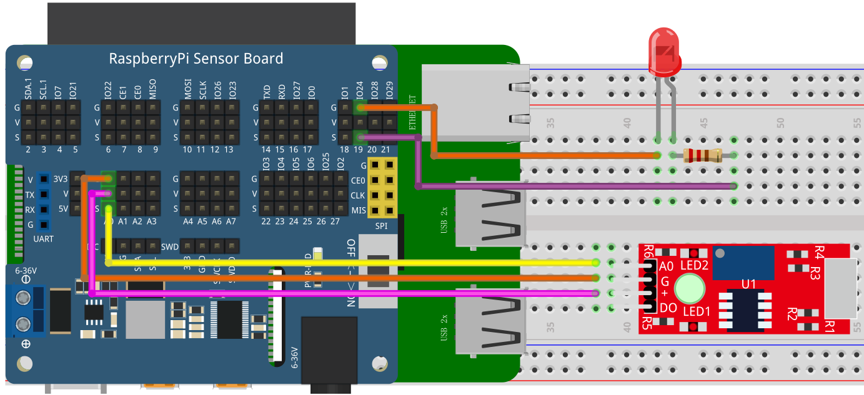

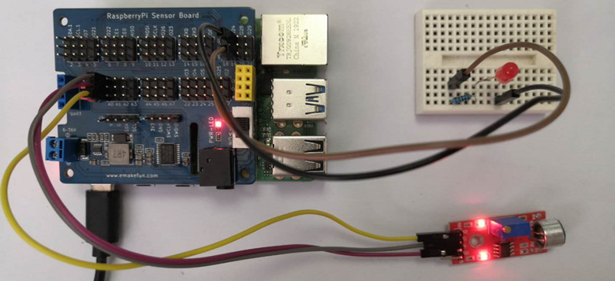

## Experimental Principle

The sound sensor convert the detected sound analog value into the voltage value.

## C++ program

|  |
| --- |
| #include <stdio.h>//Import the basic library  #include <wiringPi.h>//Import the Raspberry Pi WiringPi encoding IO control library  #include <wiringPiI2C.h>//Import the Raspberry Pi WiringPi coding I2C control library  int LEDPIN **=** 24**;** //LED light is connected to IO0 port  int value **=** 0 **;**  float voltage **=** 0.0 **;**  int main**()**  **{**  wiringPiSetup**();**  wiringPiI2CSetup**(**0x04**);**  pinMode**(**LEDPIN**,** OUTPUT**);**  **while(**1**)**  **{**  value **=** wiringPiI2CReadReg8**(**0x04**,** 0x10**);**  **if(**value **>=** 100**)**  **{**  digitalWrite**(**LEDPIN**,** HIGH**);**  delay**(**500**);**  **}else{**  digitalWrite**(**LEDPIN**,** LOW**);**  **}**  printf**(**"%d\n"**,**value**);** // Print Value  delay**(**1000**);** // Delay for 1 second  **}**  **}** |

## Python program

|  |
| --- |
| import time  import smbus as smbus  import RPi**.**GPIO as GPIO  buzzer **=** 27  ADC**=**smbus**.**SMBus**(**1**)**#Declare to use I2C 1  GPIO**.**setmode**(**GPIO**.**BCM**)**  GPIO**.**setup**(**buzzer**,** GPIO**.**OUT**)**    **while** True**:**  ADC**.**write_byte**(**0x04**,** 0x10**)**#Write a byte to the slave  val **=** ADC**.**read_word_data**(**0x04**,** 0x10**);**  **if** val **<=** 550**:**  count **=** count **+** 1  **else:**  count **=** 0  **if** count **>=** 2**:**  GPIO**.**output**(**buzzer**,** True**)**  time**.**sleep**(**0.8**)**  **else:**  GPIO**.**output**(**buzzer**,** False**)**  print**(**val**)**#Raspberry Pi reads the data returned by the expansion board **and** prints it out  time**.**sleep**(**1**)**#Delay 1 second |

## Java program

|  |
| --- |
| **import** com**.**pi4j**.**wiringpi**.**I2C**;**  **import** com**.**pi4j**.**wiringpi**.**Gpio**;**  public class Thermistor **{**  static int led_pin **=** 24**,** value **=** 0**,** fd**;**    static **{**  Gpio**.**wiringPiSetup**();**  fd **=** I2C**.**wiringPiI2CSetup**(**0x04**);**  Gpio**.**pinMode**(**led_pin**,** Gpio**.**OUTPUT**);**  **}**  public static void main**(**String**[]** args**){**  **for** **(** **;** **;){**  value **=** I2C**.**wiringPiI2CReadReg16**(**fd**,** 0x10**);**  **if(**value **>** 100**)** **{**  Gpio**.**digitalWrite**(**led_pin**,** Gpio**.**HIGH**);**  Gpio**.**digitalWrite**(**Buzzer**,** Gpio**.**HIGH**);**  Gpio**.**delay**(**1000**);**  **}** **else** **{**  Gpio**.**digitalWrite**(**led_pin**,** Gpio**.**LOW**);**  Gpio**.**digitalWrite**(**Buzzer**,** Gpio**.**LOW**);**  **}**  **}**  **}**  **}** |

## Experimental Effect

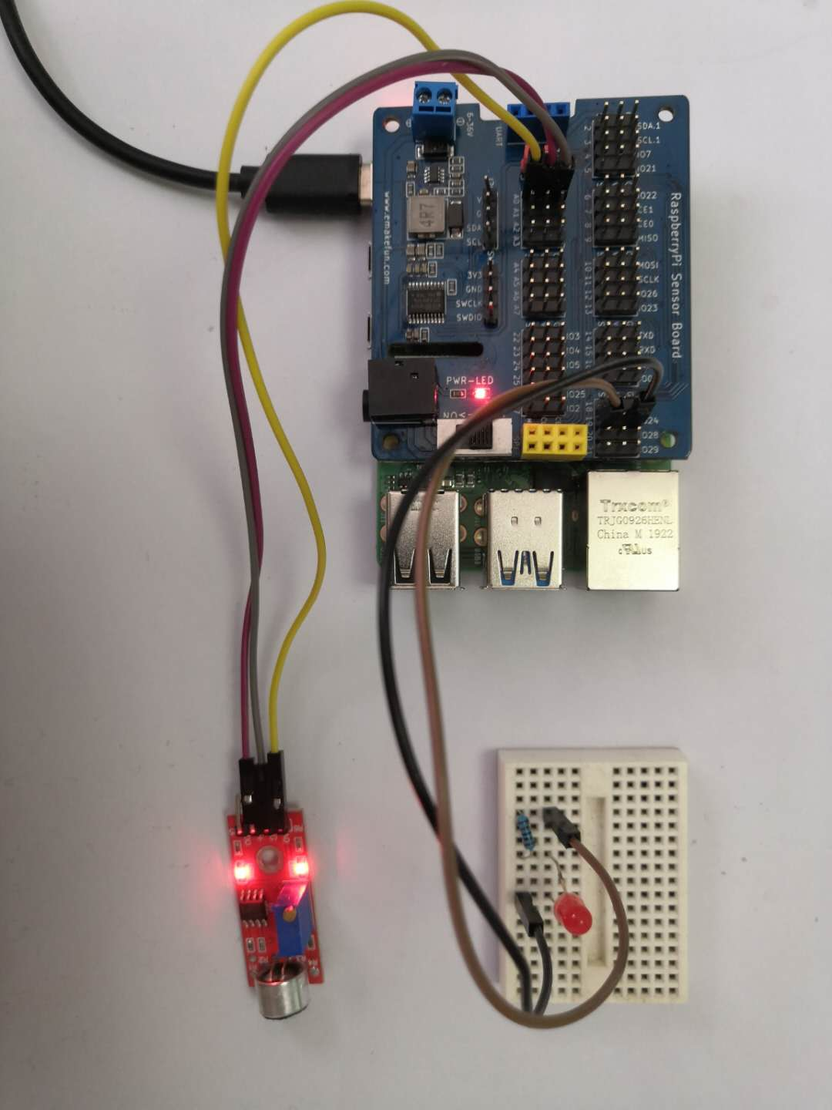

While the sound sensor detects that the surrounding sound is greater than the threshold and it turns on the LED otherwise turns off the LED light.